NAME: KRINA PANCHAL

REGISTRATION NUMBER: 20BIT0051

Ans 1) My role is to make a smart AI chatbot

2)I learned the complete process because I didn't know how to make a chatbot

3)Nope, I didn't take any course but I did take a lot of help from YouTube and google

4)Codes for the libraries I installed and imported:

pip install newspaper3k

pip install nltk

from newspaper import Article

import random

import string

import nltk

from sklearn.feature_extraction.text import CountVectorizer

import numpy as np

import warnings

from sklearn.metrics.pairwise import cosine_similarity

5)I found out an article on chronic kidney disease so i basically made a simple chatbot which helps user resolving queries about the chronic kidney disease

6)Screen shot of my chat bot

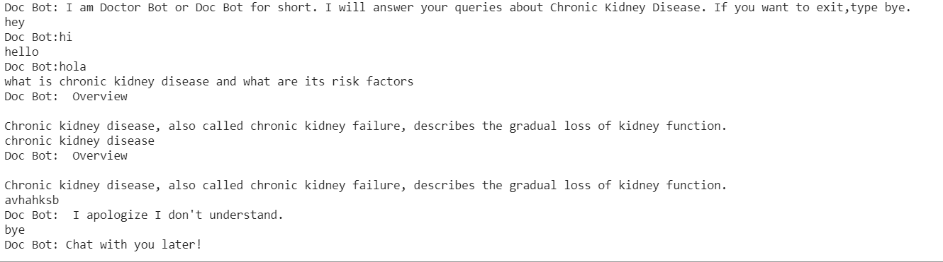

I have made the chatbot on google collab so here is the link:

<https://colab.research.google.com/drive/11VDFpptuMqasNBNQKhZu7Ug_HP423dRl?usp=sharing>

Thank You.

Github repo link:

<https://github.com/krina1912/Chat-bot>